CICD Documentation

1. **Why We Need CICD Pipeline:**

**Using this method we can avoid deploying our Jar or war file to server manually .**

**Benefits : Only We need to push the code from our local repository to the main branch of our git repository and then from there deployment will start automatically without each and every time we push the code to git repo.**

**And thus it can avoid manual deployment of our jar or war file to git repo .**

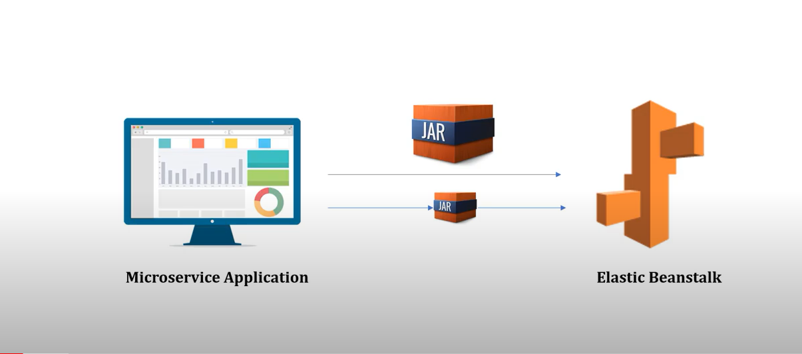

1. **Steps to build code pipeline in aws**

* **Create the application (any web application maven or gradle)**
* **Add buildspec.yml file and add it to the root directory of your project**

**Note : buildspec.yml file contains the command which will run to .**

**Below is the sample buildspec.yml file**

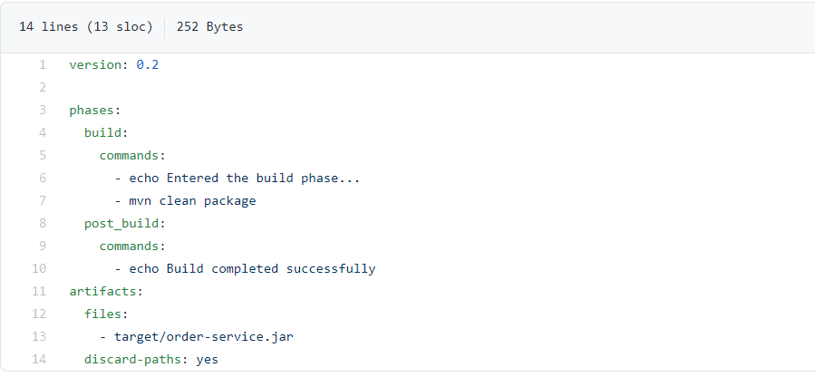

**Note: at line no. 13 the jar name configured here should be same as jar name present in application pom.xml file inside <build><plugins><plugin> tag**

**Eg:**

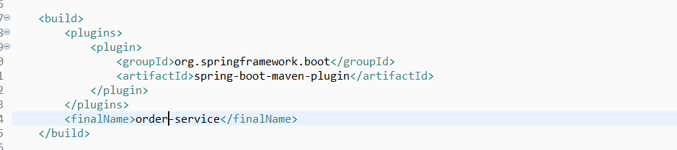

* **In our case order-service-master.zip file is there, where buildspec.yml**

**Has all the configuration.**

* **Add this file to your git repositoty using below command :**

**Note : open the git bash in the root folder of your project and type below commands**

* + **Git init**
  + **Git commit -m “commit message”**
  + **Git branch -M branch name**
  + **Git remote add origin your remote_branch_link(that you will get in the git repo)**
  + **Git push -u origin branch_name**
  + **Now go to your github url and refresh it it will be there on github.**
* **Create elastic beanstalk environment on aws .**

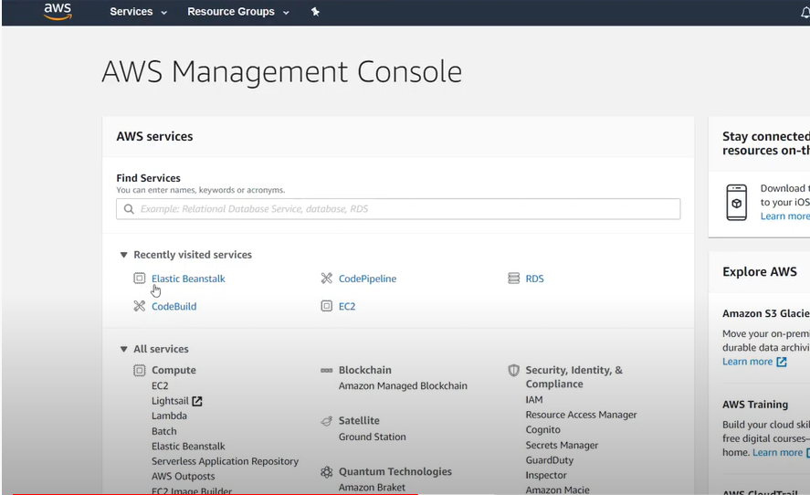

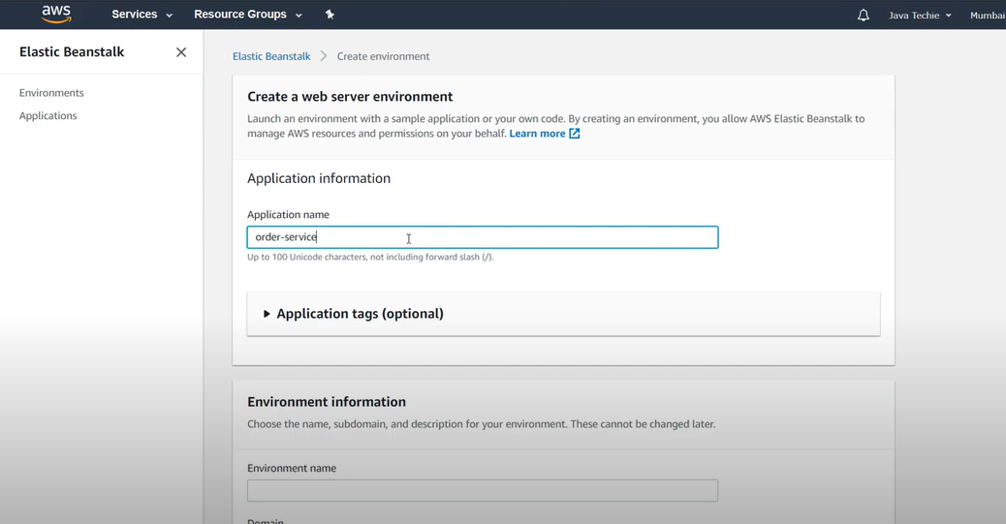

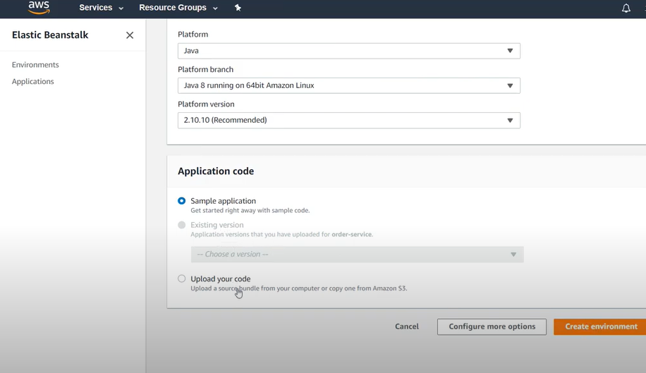

**Here no need of deploying the code by selecting upload your code or sample application from above screen shot as it will be taken care by CICD process.**

* **Create the code PipeLine in aws to tell the aws from which repository , branch and git url the deployment should happen.**

**For this search the code pipeline from aws and then fill below details :**

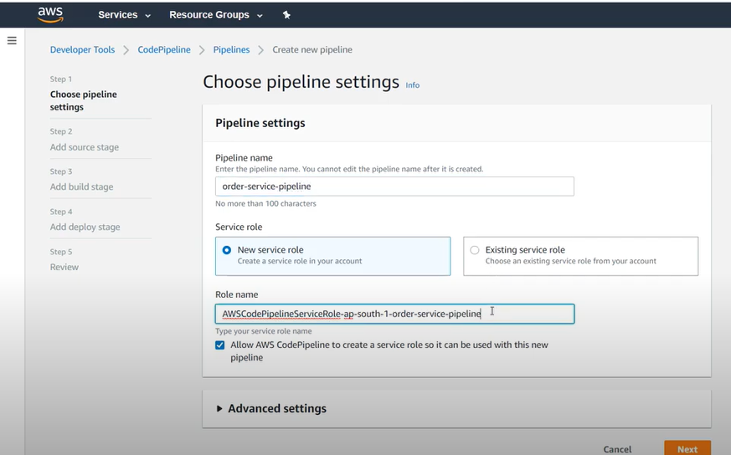**in above field only need to enter pipeline name And then click on next.**

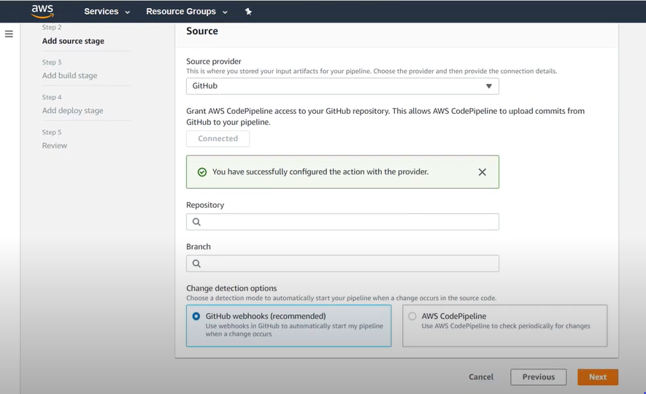

**In above fields select the source provider and click on connect and then authenticate your git repository by entering git credentials here and then it will show**

**“You have successfully configured the action with the provider”**

**And then enter Repository name of the github , and Branch name of github and branch name .**

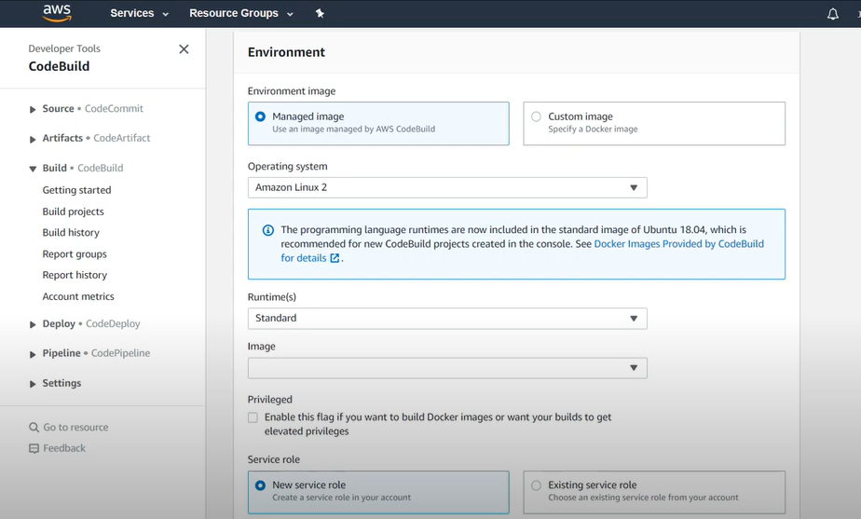

**Enter above details in Environment.**

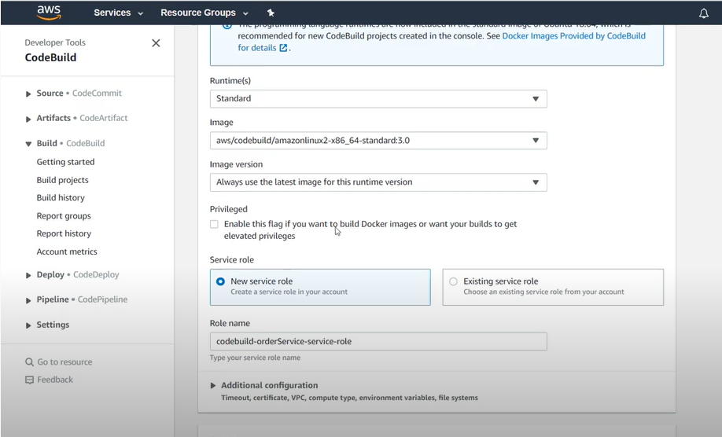

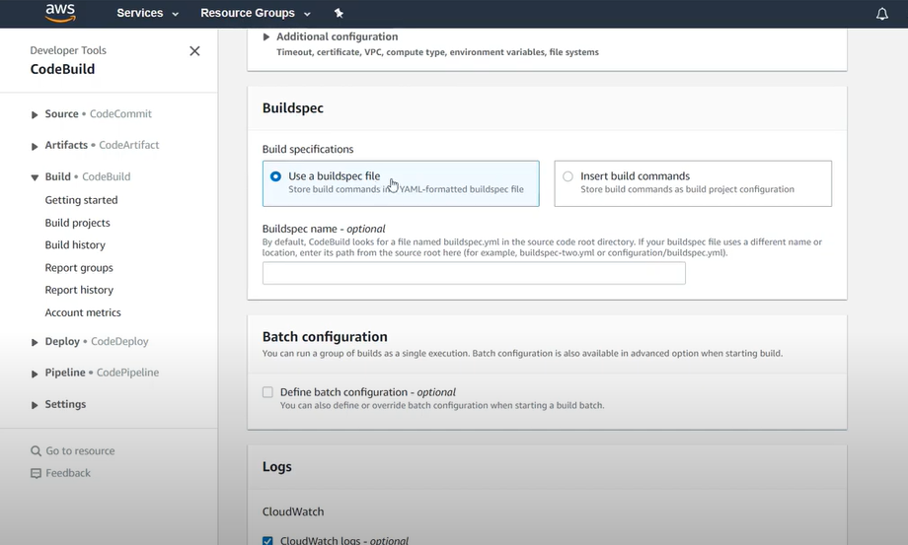

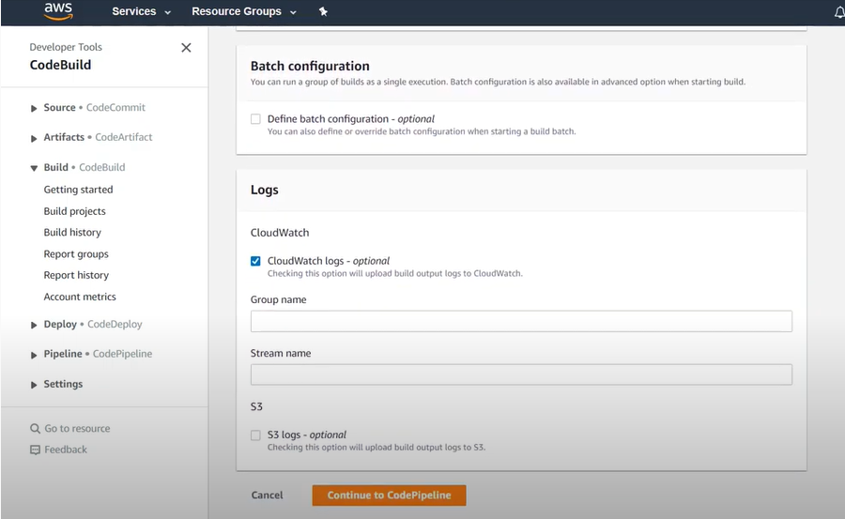

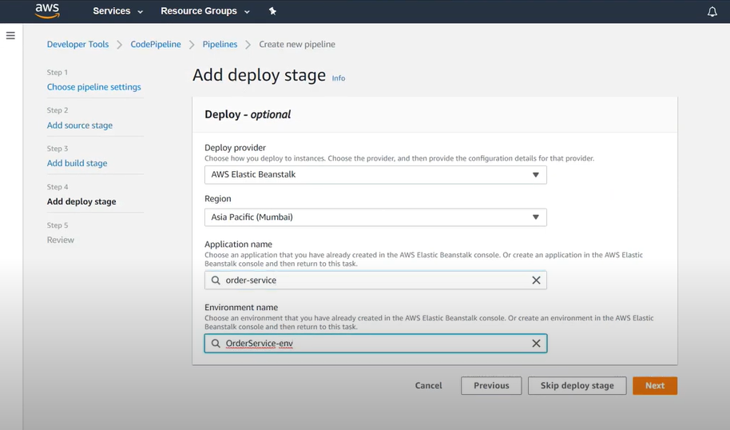

**Application name present above will come once the elastic beanstalk instance is created and from here we can select that .**

**Click on next 🡪 create pipeline**